Walkthrough – Evil Box 1

Contents

Host Discovery 2

Nmap 2

Nikto 2

Dirb 2

FFuF 3

Viewing Website 3

Cracking SSH Key 4

Exploitation 4

Find Binaries 4

Find Writable Files 4

OpenSSL 4

Flag 1 5

# Host Discovery

# Nmap



# Nikto





# Dirb



I then searched for the extensions since that is what is required.

Found a file called evil.php. It is key to note that both index.html and evil.php have a response code of 200. This could be there are parameters. Which then we can turn to fuzzing.

# FFuF

This command should reveal any hidden parameter that can execute the command /etc/passwd.

The result is command.

# Viewing Website

The secret directory doesn’t show anything, I don’t know why. There is nothing in the source code.

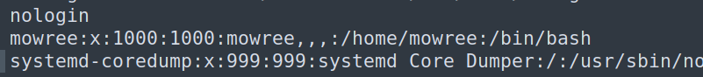Robots.txt contains text that says “Hello H4x0r”. This text might be valuable later.

In the /etc/passwd file there contains an entry with ‘mowree’.

php://filter/convert.base64-encode/resource=evil.php

php://filter/convert.base64-encode/resource=index.html



# Cracking SSH Key





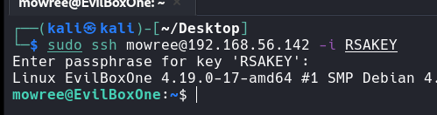

NOTE: RSA key must be in the correct format, google the format if need be.

# A screen shot of a computer Description automatically generatedExploitation

## Find Binaries

I didn’t find any binaries besides su which peaked my interest however it wasn’t any use with the root password.

## Find Writable Files

**Command**: find / -perm -o+w 2>/dev/null



This means we can modify the file and add our own password to the root account.

## OpenSSL

Generate a new password for root.

Add it.

Switch user.

# Flag 1

In the root directory, the flag was waiting for me.